MILESTONE 5
Architecture Design
Date: 26 July 2026
Updated: 5 August 2026
Status: Proposed design for review — final sign-off depends on the Gate 1 decisions, and the in-node approach must be proven by the prototype (gate RG4).
Substrate baseline: design claims reviewed against f1r3node-rust v0.4.18 and re-checked against v0.4.45.
Audience: SNet stakeholders approving the design direction and the team implementing the follow-on proof of concept.
Covers: How the system runs on F1R3FLY: the invariants, system and trust boundaries, state authority, components, runtime flows, interfaces, deployment topology, and what is in V1 versus deferred.
How the system runs on F1R3FLY: boundaries, state authority, flows, and the V1/deferred split.

1. Executive summary
In plain terms, the architecture does two things and keeps them strictly apart. It permanently records evidence — who said what about whom, when, in what context, and based on what — with nothing ever edited or deleted; corrections are new events that supersede or invalidate old ones, and every derived result can be traced back to the events it came from. And it derives scores as views: a score is computed from the evidence by an explicit, versioned policy, so policies can change without rewriting history, and any published result names exactly which policy version and which body of evidence produced it. Two consequences do a lot of work: disagreement stays visible (conflicting evidence answers "disputed" instead of being averaged away), and ignorance stays visible (every answer carries a coverage statement, so "we saw nothing wrong" is never confused with "we watched and it behaved"). Throughout, a signature proves only who made a statement — never that the statement is true.

1.1 Architectural paradigm
V1 is an event-sourced evidence application with CQRS-style read separation and deterministic snapshot projections:
- Authorized commands append evidence, dispute, and correction events; they do not overwrite history.
- Accepted writes append to the evidence state; queries and projections derive from it.
- Evidence queries assemble inspectable structured reputation objects from canonical evidence and rebuildable indexes.
- Projection queries return separately typed, policy-derived epoch results.
- Consumer shards accept a projection only through their own verified local import.
This is a logical application pattern, not a claim that a separate CQRS framework or event-store product will be introduced.

1.2 Primary architecture decision
Use one permissioned, multi-validator F1R3FLY reputation shard for the follow-on V1 prototype. Keep the evidence state and other consensus-visible reputation state inside the node-hosted shard. Do not introduce a sidecar database as a second source of truth. Rebuildable indexes, query caches, payload stores, and off-chain clients may exist only when their derivation, availability, and trust status are explicit. Reputation does not alter F1R3FLY consensus in V1.
The design still needs prototype validation.
The reviewed node already provides
- Signed deploys; CBC Casper/PoS consensus; and Rholang/RSpace execution.
- LMDB-backed rspace++ history and checkpoints; PathMaps; HTTP/gRPC and WebSocket surfaces; shard identifiers; and epochs.
The reputation layer still needs
- Schema, authority, provenance, invalidation, query, projection, dispute, privacy, and snapshots.
- Native cross-shard reads, foreign-finality verification, and RSpace membership proofs.

1.3 Decision-status legend
Status | Meaning
Established design constraint | Accepted architectural rule; implementation not yet proven
Gate 1 dependent | Contract must be decided at the named freeze before implementation can rely on it
Candidate implementation | Plausible mapping to the current node, subject to RG4 measurement or prototype evidence
Deferred | Outside V1 unless separately promoted through the Open Question Register and roadmap

2. System context
The reputation shard is an evidence authority for its own finalized application state. It is not the authority for an external chain's finality, a universal reputation score, or a consumer shard's acceptance decision.
Figure 1 — System context.
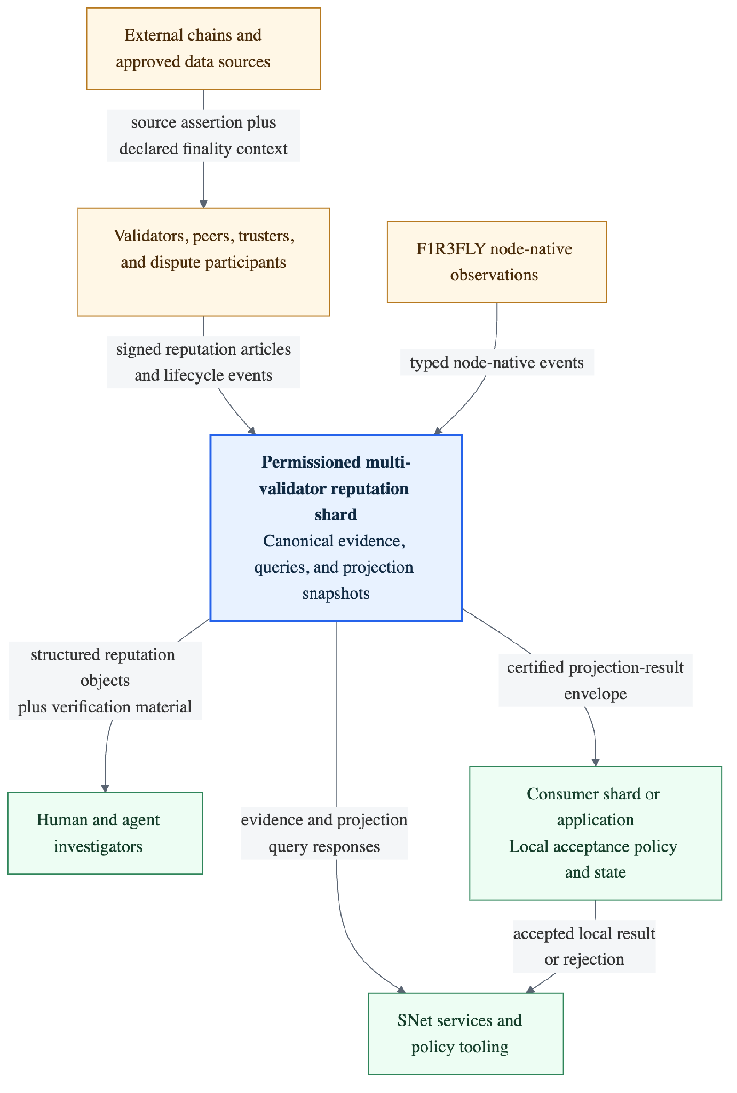
Editable Mermaid source | SVG export

Context rules
- An issuer signature proves attribution and applicable submit authority; it does not prove truth or completeness.
- Reputation-shard consensus proves what the shard finalized; it does not prove a foreign source's finality without a declared bridge, light client, or attestor contract.
- A query response is not consumer consensus state. Only a verified consumer-local import can establish that state.
- Evidence and results do not automatically carry over between types or scopes. Any cross-context reuse must follow an explicit, bounded, versioned rule. V1 defines no automatic carry-over.

3. V1 deployment topology
The proof of concept runs the same reputation application logic on each validator in a controlled multi-validator reputation shard. Clients may submit or query through a node API, but final authority comes from shard execution and finalization rather than the API process that served the request.
Figure 2 — V1 deployment topology hypothesis.
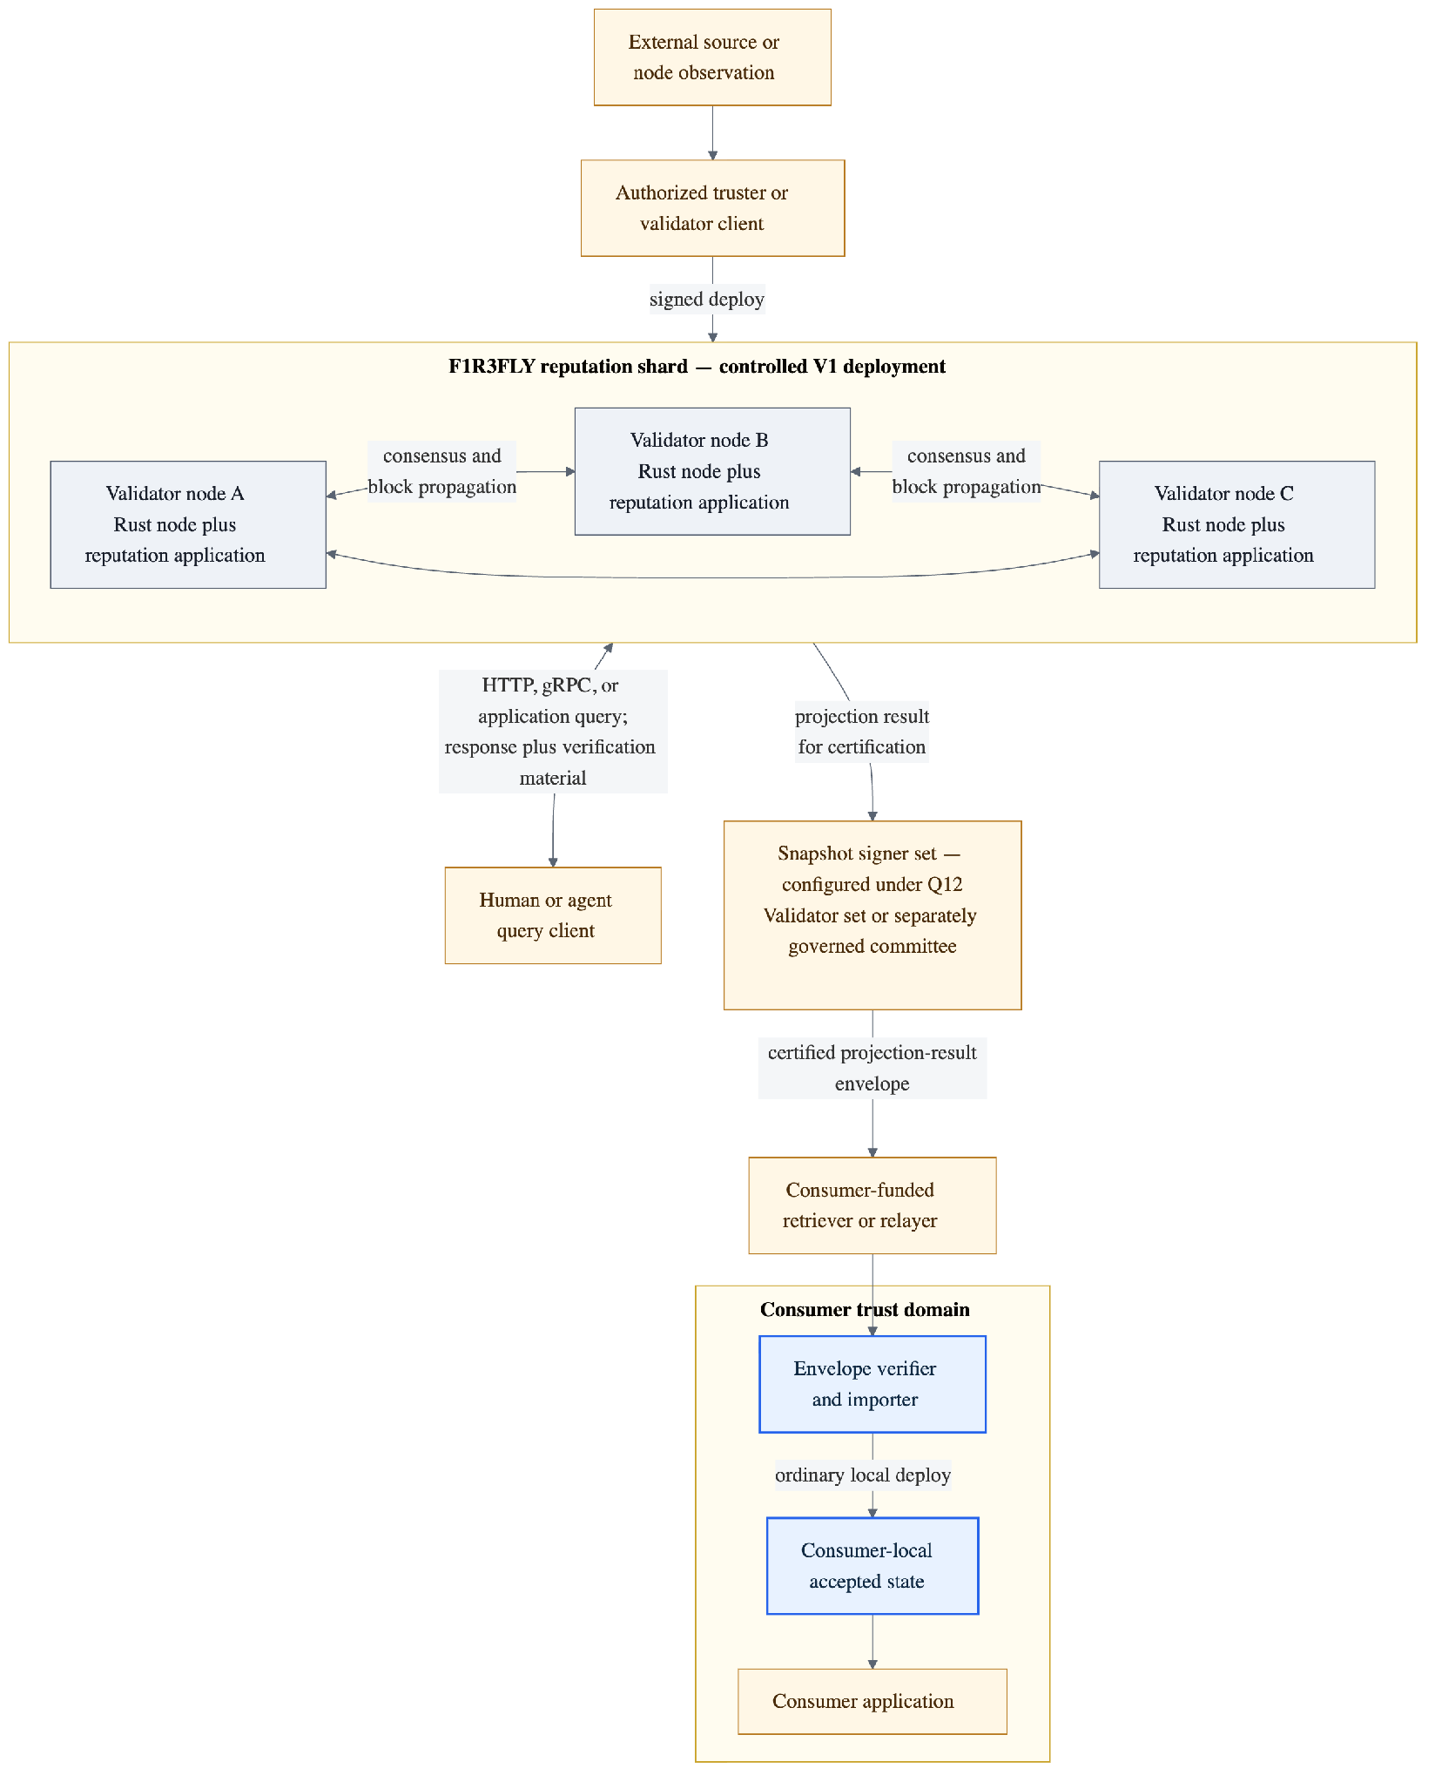
Editable Mermaid source | SVG export
The diagram is a topology hypothesis, not a fixed validator count or production deployment. Q12 decides the validator/certifier topology and Q26 sets the workload and recovery bounds. Cloud provider, region layout, production autoscaling, and production disaster-recovery objectives are deliberately not selected by Milestone 5.

4. Logical component architecture
The component boundary distinguishes current node substrate from reputation-specific capabilities that the proof of concept must add. It does not prematurely choose whether every reputation component is implemented in Rholang, native Rust, or a measured combination; Q26 and RG4 decide that physical placement.
Figure 3 — Logical component architecture.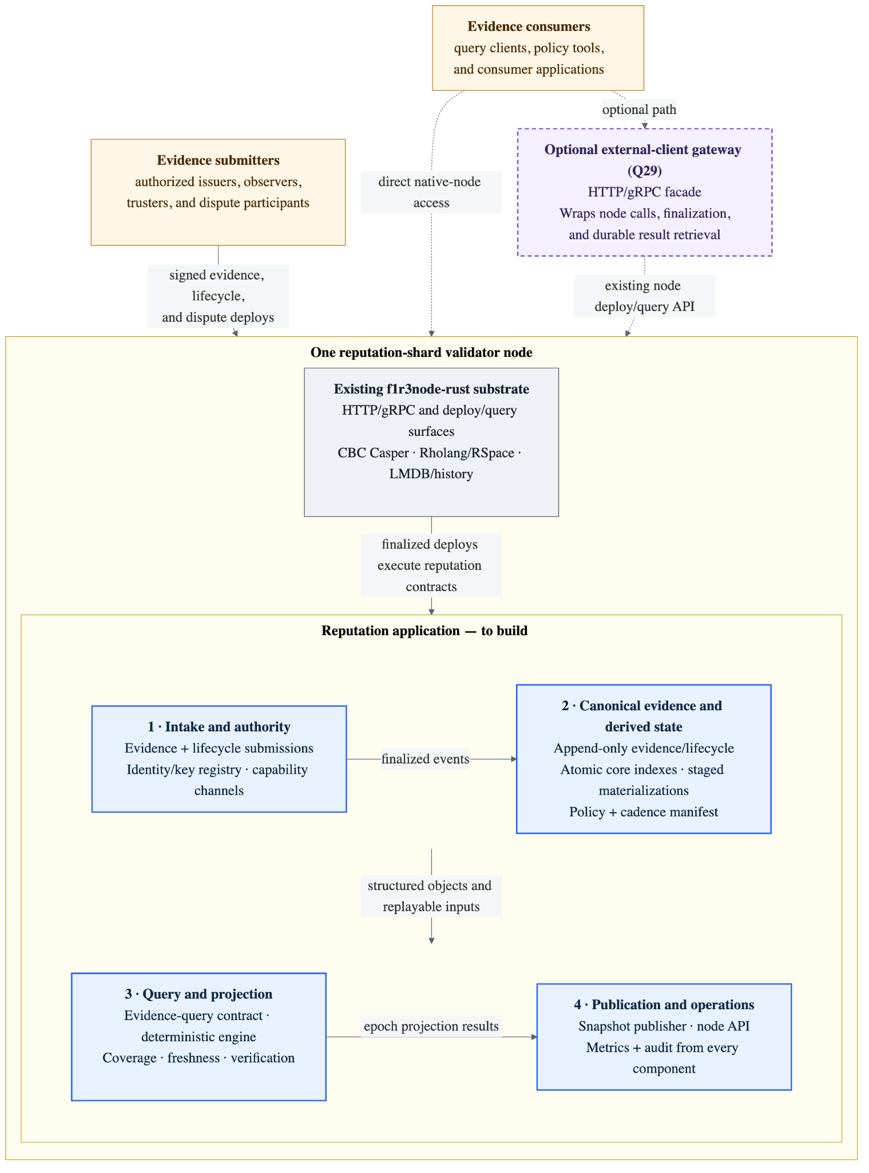

The four numbered areas show the reputation application's main responsibilities and data flow: intake and authority, canonical evidence and indexes, query and projection, and publication and operations.

4.1 Component responsibilities
Component | Owns | Must not become
Evidence submission contracts | Schema-defined envelopes for claims, observations, attestations, counterclaims, and refutations. Capability-secured entry points are separated by event kind and may additionally be partitioned by type, scope, or state key. | A single high-contention Rholang channel or an alternative evidence authority
Identity and authority registry | Stable subject, effective controller/key bundle, action capability, rotation, and revocation | A mechanism that silently grants authority across types or scopes
Canonical evidence and lifecycle store | Append-only evidence and lifecycle events, provenance references, policy manifests, and application evidence roots | A mutable score table, current-status cache, or single unpartitioned history channel
Core evidence indexes | Bounded subject/type/scope/time lookup, outgoing provenance, direct incoming dependency, and omission/gap support required by V1 reads and correction targeting | Independent authority, an unbounded write set, or state that may lag its accepted evidence event
Staged materializations | Larger traversals, affected-context sets, rebuilt indexes, and other query acceleration that cannot safely finalize with one evidence event | Partially visible state or a second evidence authority
Lifecycle and correction contracts | Capability-secured lifecycle and dispute actions (supersession, revocation, invalidation, appeal); target validation; and binding of the applicable correction-policy version. Reverse-dependency processing later derives affected result contexts for policy-governed recomputation. | Overwrite or erase the original evidence event, let a submitter choose correction impact, or force all evidence writes through one channel
Evidence-query contract | Query semantics for structured reputation objects, proof material, coverage, freshness, and authorization-aware payload views | A required off-chain service, projection engine, or unversioned adjudicator
Active projection policy and cadence registry | Consensus-visible active policy manifest, cadence, epoch/cutoff derivation, trigger capability, and execution idempotency | An off-chain scheduler choosing an uncommitted policy, cutoff, or result
Deterministic projection engine | Periodic policy execution over one declared evidence root | Canonical evidence or automatic economic control
Snapshot publisher | Complete projection-result binding and applicable certification | Proof of foreign finality or consumer acceptance by itself
Replay-equivalence audit harness (PoC/audit only) | Independent full projection rebuild and comparison with optimized dependency-derived recomputation under the same pinned evaluation context | A consensus participant, canonical state owner, or routine step for every correction
Observability and audit surface | Ingestion lag, coverage gaps, projection age, replay/index cost, dispute status, and import failures | A second canonical event store
These are logical responsibilities, not a one-contract-per-row deployment prescription. V1 deliberately does not funnel reputation writes through one untyped Rholang ingress channel or store the complete history in one persistent channel. Meredith's 2026 Rholang sketch (p. 9) separates claim, attestation, and reputation-query channels. Goertzel's 2026 contract interface (p. 6) separately names evidence submission, snapshot publication, query, and dispute operations, while his layered sketch (p. 10) treats ingestion as one semantic layer without prescribing physical Rholang state layout. Full source details are in the companion Research and Tokenomics Synthesis references.
V1 therefore uses separate capability-secured contract/channel families for evidence submission, lifecycle/correction, evidence query, and projection-result query. Evidence submission may be split further by event kind and partitioned state key when RG4 measurements justify it. The state-changing contracts share canonical envelope fields, authorization invariants, a shard-wide event-ID/idempotency domain, rejection/receipt semantics, and one canonical evidence-event model, but they need not share an endpoint or handler. Small shared coordination/state keys such as an ID registry, evidence-root accumulator, or epoch manifest are permitted only when explicitly identified and shown by Q26/RG4 not to become an unbounded history container or unacceptable serialization point.

5. State authority and commitment model
The model distinguishes five commitments: source event or payload — what the issuer supplied; finalized shard history — the accepted deploy and block history; RSpace checkpoint — execution state; application evidence root — the reputation events accepted by the application; and projection result root — the output of a declared policy. They may be linked for replay and verification, but they are not interchangeable. Consumer acceptance is a separate, local authority boundary.
Figure 4 — State authority and commitment model.
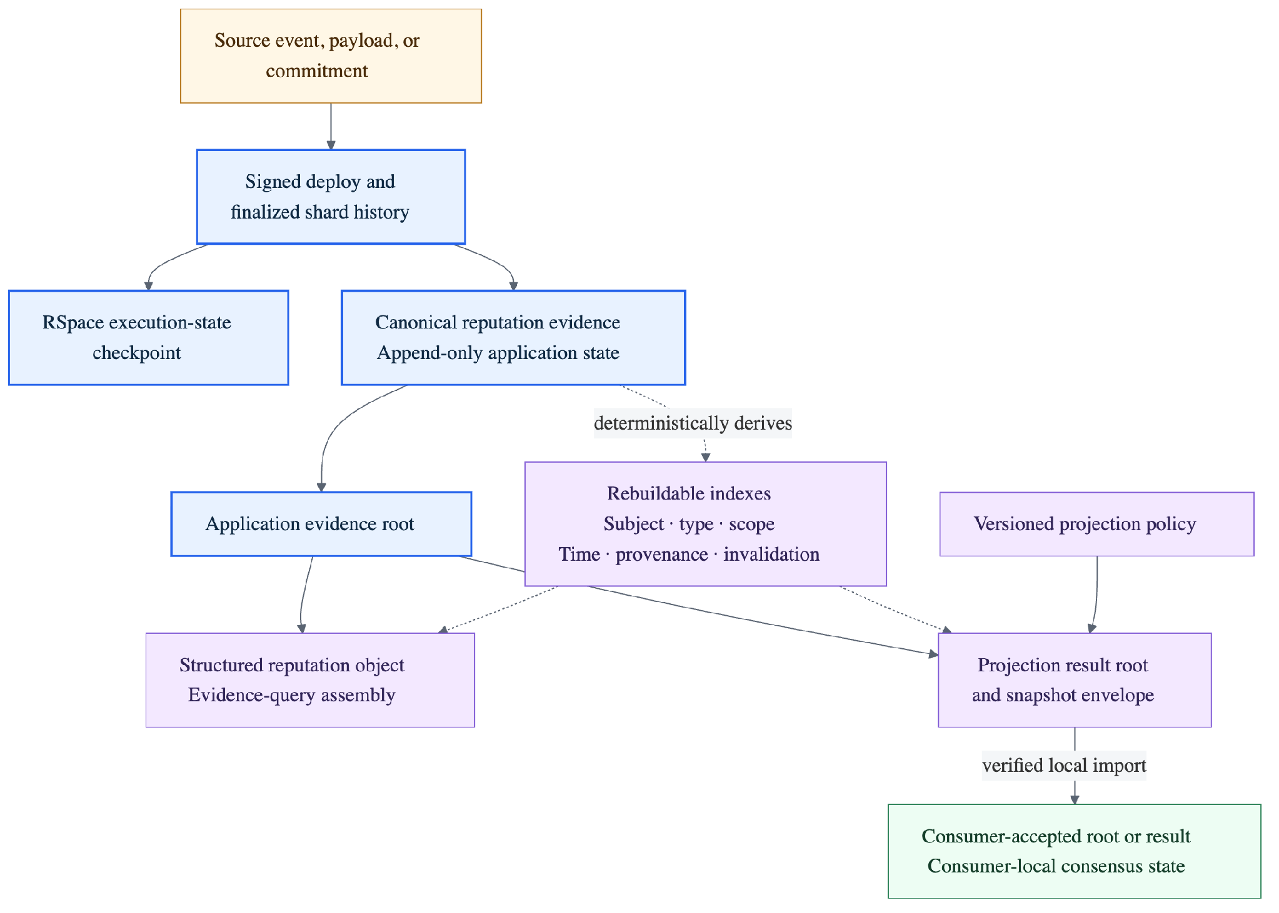
Editable Mermaid source | SVG export

5.1 State ownership
Layer | Contents | Authority and recovery rule
Finalized deploy and execution history | Signed deploys, blocks, execution events, and checkpoints | Consensus source of record for shard execution
Canonical reputation event state | Evidence envelopes, subject/authority references, provenance links, lifecycle events, policy manifests, and application roots | Consensus-visible application authority; event history is append-only
Payload availability | Public payloads or commitments plus availability references for private or large evidence | Policy-defined; a commitment does not establish availability or completeness
Core lifecycle state and evidence indexes | Current validity/dispute status; subject/type/scope/time lookup; outgoing provenance; direct incoming dependency; and omission/gap state | Deterministic and rebuildable from canonical events, but required bounded entries finalize in the same application transaction as the event they index
Staged indexes and materializations | Larger affected-context traversals, rebuilt index versions, projection lookup, and optional query acceleration | Built under an inactive version and made visible only after complete and verified; never authority for cross-context reuse
Structured reputation objects | Query assemblies over one declared context and evidence root | Reconstructable response objects; not canonical truth
Projection snapshots | Complete versioned result binding over a declared evidence root | Derived but committed application output; immutable after publication
Query caches and mirrors | Consumer-specific acceleration | Non-canonical; loss must not change authoritative answers
Consumer-accepted state | Verified result accepted by an ordinary consumer-local deploy | Authoritative only inside that consumer's trust and consensus domain
The current preference is to keep authoritative reputation state and required core indexes in the F1R3FLY shard, while allowing payload storage, separately staged materializations, query objects, and consumer caches to be in-node or off-chain as appropriate. Q5 must define the placement, persistence, availability, and trust guarantees for each layer.

5.2 State consistency and publication invariants
- Atomic core state. An accepted evidence or lifecycle event and its required bounded lookup, provenance, direct reverse-dependency, idempotency, and receipt entries finalize in one application transaction.
- No partially visible derived state. Work that cannot fit that atomic boundary is built in idempotent chunks under an inactive version. One finalized activation reference makes it queryable only after the declared completion and validation checks pass; abandoned work is never activated.
- Every read names its state. A response identifies the finalized block and evidence root used, plus the active version of any separately published index or materialization. It never combines versions.
- Projection cadence is separate. Periodic projection snapshots deliberately use a declared epoch or cutoff and may lag current evidence by that published boundary; this is not index inconsistency.
- Delivery does not determine consistency. Polling, node notifications, RSpace continuations, reified RSpaces, and optional API adapters must preserve the same query contract and state binding.

6. Logical state and index layout
Canonical evidence and rebuildable indexes use separate namespaces so indexes can be discarded and reconstructed without altering source history. A separately published index or materialization also carries a version and activation reference; a bounded core index updated atomically with its event need not introduce a separate publication cycle.
The logical partition dimensions are:
canonical evidence: subject x type x scope x event time or epoch x event ID
outgoing provenance: derived event or result -> material input IDs
incoming dependency: input event ID -> affected evidence objects and result contexts
coverage manifest: observation boundary x type x scope x epoch -> expected or monitored, observed, missing, unavailable
projection lookup: policy version x subject or aggregation x type x scope x epoch
These are logical access requirements, not a frozen key encoding.
Do not accumulate the complete evidence graph or claim history in one persistent channel. PathMaps may encode prefix-compressed partitions or adjacency projections, but the current Rholang integration reconstructs or scans data for some operations and is not yet proven as the physical index for graph-shaped access. RG4 must benchmark exact lookup, neighbor enumeration, bounded traversal, update and re-serialization, reverse invalidation, checkpoint, and replay against both total evidence size and local degree/fanout before Q26 fixes the layout.

7. Primary runtime flows

7.1 Evidence submission and evidence query
The first vertical slice does not require a reputation score. It proves that canonical evidence can be submitted, finalized, inspected, and verified without passing through a projection.
The flow is split at the canonical evidence boundary: Figure 5a covers submission and finalization, while Figure 5b covers evidence retrieval and verification.
Figure 5a — Evidence submission and finalization.
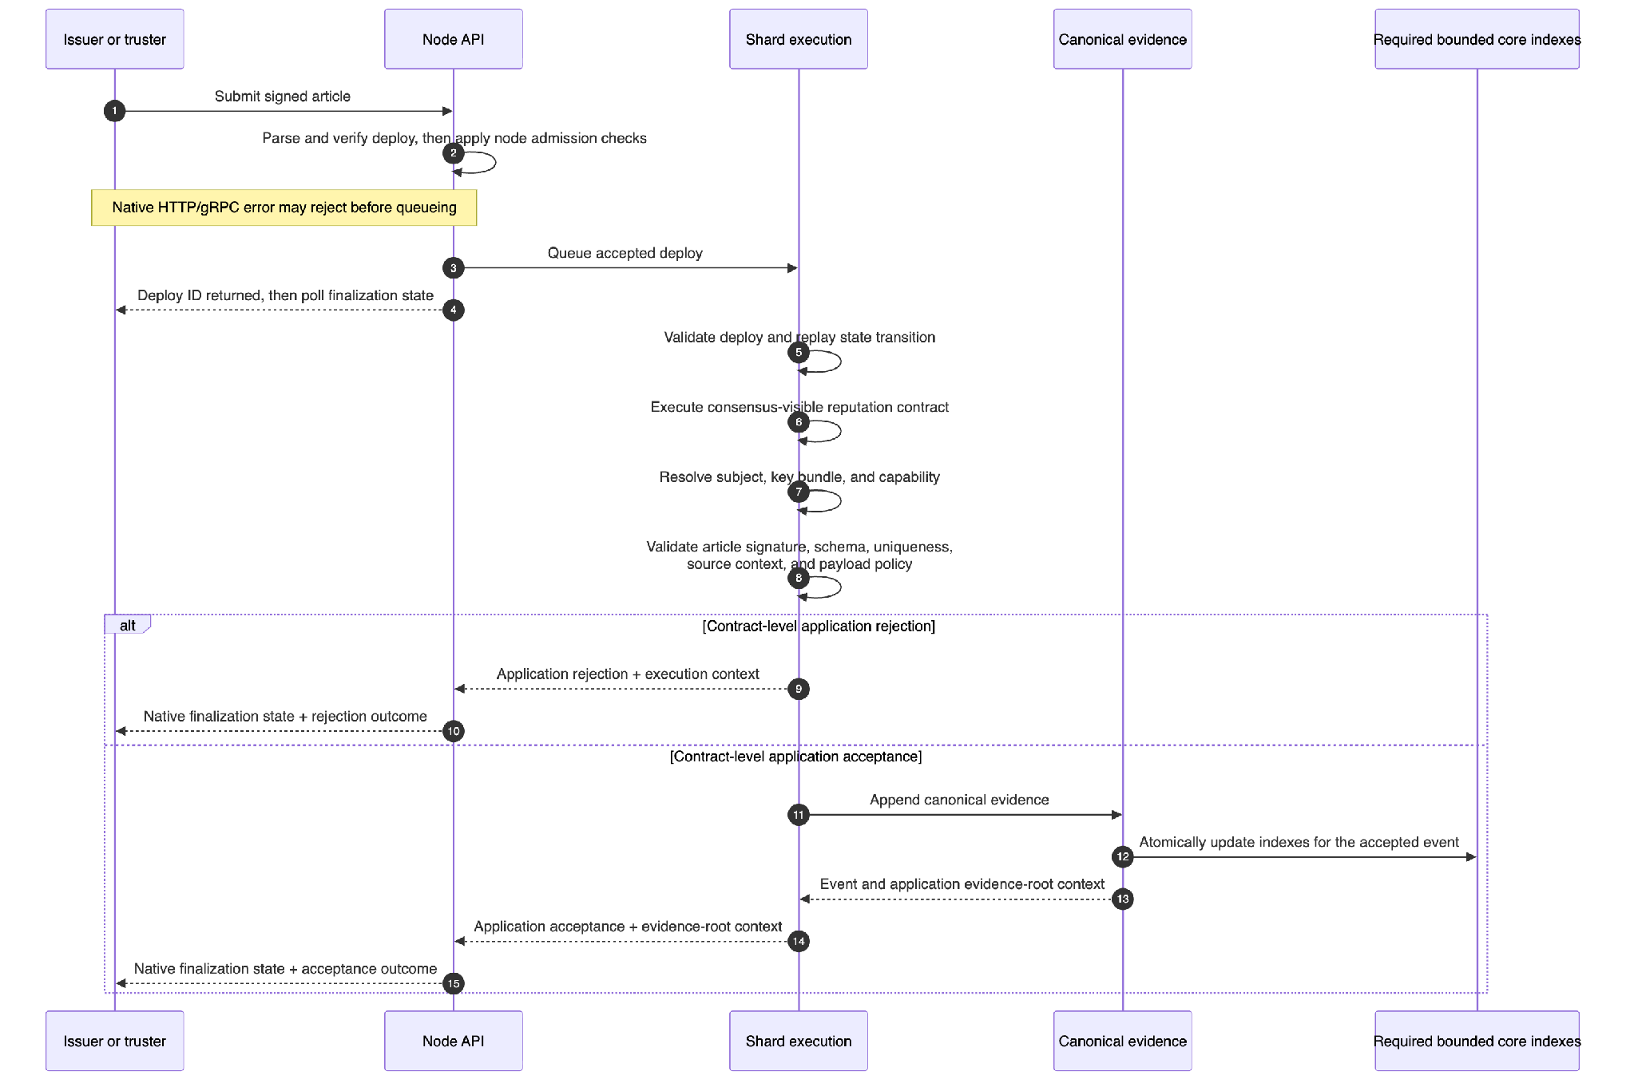
Editable Mermaid source | SVG export
Figure 5b — Evidence query and response.
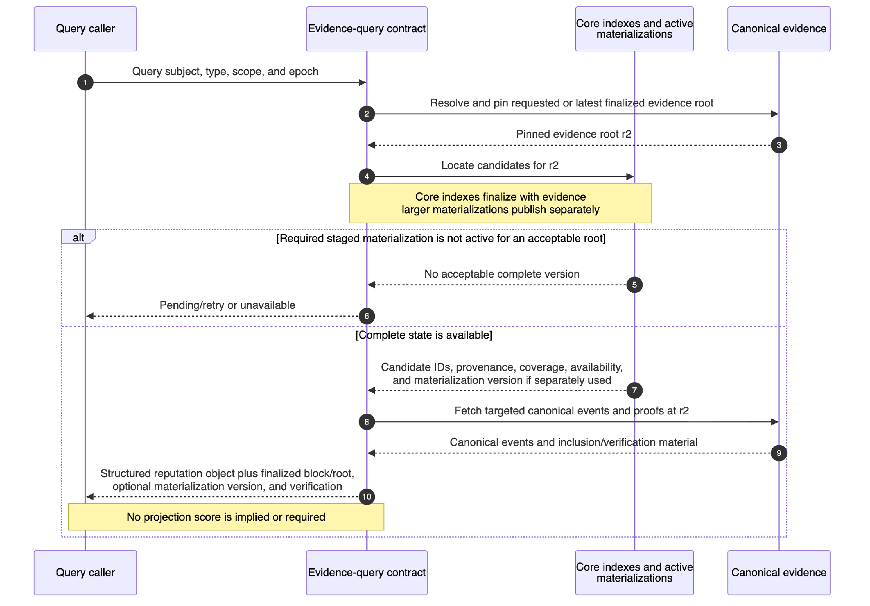
Editable Mermaid source | SVG export
Figure 5b shows the evidence-query contract, not a required off-chain service. The contract resolves the requested root or the latest finalized evidence root, uses the core indexes and any required active materialization to locate candidate event IDs, then fetches the targeted canonical events and proofs. Core indexes are expected to finalize with the events they index. If a query depends on separately staged derived state, it may wait for bounded completion, answer from an explicitly identified older finalized root, or return unavailable when neither is acceptable. Canonical evidence remains authoritative; indexes only accelerate and organize access.
On-chain callers can use the contract directly through Rholang/RSpace interaction. External callers can use the node's existing deploy, finalization-status, and data-query surfaces; block-finalization notifications can trigger polling for a durable response or status reference. An optional adapter may make that workflow more convenient, but it must not define different query semantics. Q29 selects the V1 access and completion-notification paths for each consumer class.
Coverage and completeness (Q7). A successful query must be complete for its pinned evidence state. Coverage separately describes how much relevant activity was observed — for example, observed versus assigned duties, or monitored sources and intervals with any gaps. A percentage is appropriate only when a meaningful denominator exists. Exact coverage rules remain open under Q7.
The response uses yes, no, disputed, or insufficient evidence where appropriate. It includes the applicable coverage statement and identifies missing, unavailable, redacted, disputed, or out-of-authority material. Every answer binds the finalized block and evidence root used, plus any separately published materialization version. A response never mixes state versions, and a valid inclusion proof over a favorable subset must not be presented as complete evidence.

7.2 Dispute, invalidation, and deterministic replay
Correction appends a new event that identifies its target evidence; it does not declare downstream effects. Consensus execution resolves the applicable versioned correction policy for the target's community, type, and scope and binds that policy version to the lifecycle event. Reverse-dependency processing later derives affected result contexts. The correction policy governs whether and when those contexts are recomputed, while the separate projection policy governs how results are calculated. Previously published snapshots remain immutable.
Figure 6a — Steady-state correction and affected-set derivation.
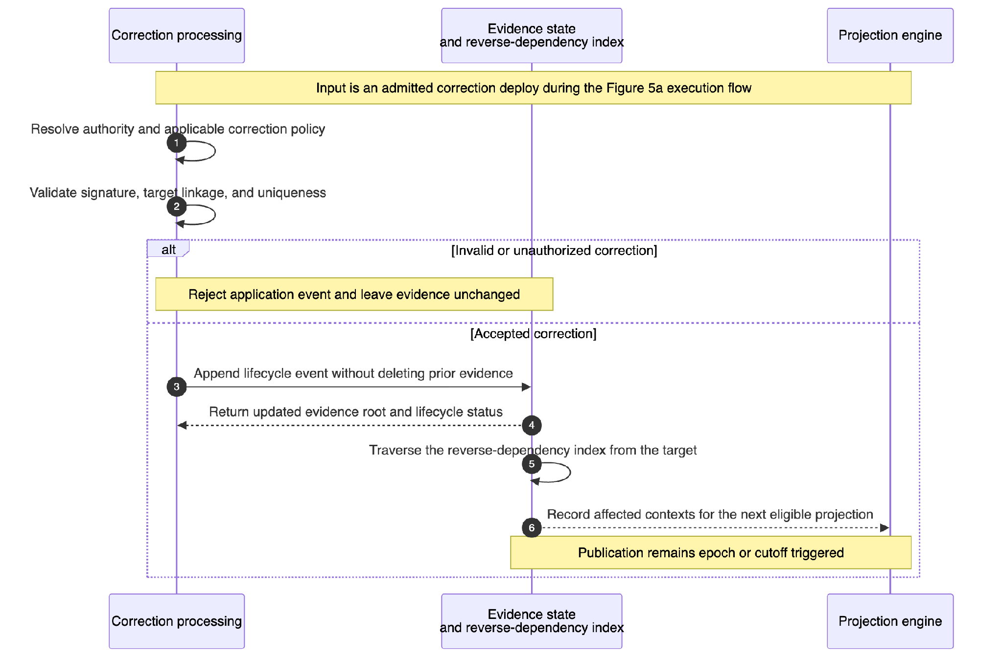
Editable Mermaid source | SVG export
Q9 and Q14 still decide dispute authority, appeal path, deadlines, provisional effect, correction horizon, and historical-restatement rules.
Figure 6a expands correction-contract execution within the ordinary admitted-deploy flow shown in Figure 5a. After a correction is accepted and finalized, reverse-dependency processing derives affected result contexts for the next eligible periodic projection; it does not publish a projection immediately.
Recomputation equivalence. Consensus establishes that validators execute the same state transition consistently. It cannot detect a dependency-traversal optimization that every validator executes incorrectly. The replay-equivalence audit harness therefore compares normal dependency-derived recomputation with an independent clean rebuild from the same canonical evidence and evaluation context.
The harness is proof-of-concept and audit tooling, not part of consensus or routine correction processing. It does not modify evidence or publish results. A mismatch indicates incomplete dependency traversal, a stale index, nondeterministic computation, or another projection defect.
Figure 6b — Incremental/full projection recomputation equivalence check.
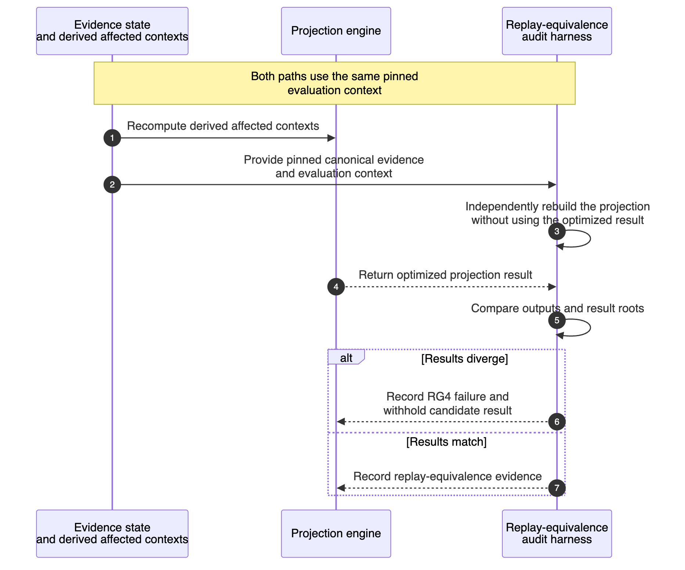
Editable Mermaid source | SVG export
Both paths use the same evidence root, correction-policy version, effective cutoff and horizon, projection policy/context, schema/runtime inputs, and declared snapshot/restatement context. A divergence fails the RG4 check and prevents the candidate result from being treated as validated.

7.3 Projection publication and consumer import
Evidence ingestion may be continuous. Projection execution and publication are periodic and epoch-bound in the current V1 direction. Consumer retrieval is funded and initiated on the consumer side rather than being a continuous per-claim push. The trigger client in Figure 7a is only an initiator: active policy, cadence, epoch/cutoff derivation, trigger capability, and duplicate suppression are consensus-visible application state. Q15 must select the first trigger principal and cadence before projection contract freeze; no API process or external scheduler may select an uncommitted policy or bypass consensus validation.
Figure 7a — Projection trigger and deterministic computation.
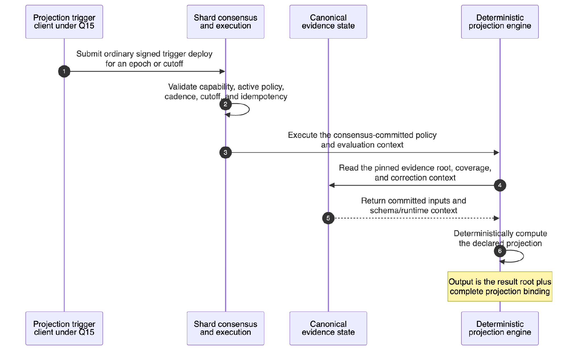
Editable Mermaid source | SVG export
Figure 7b — Snapshot certification and consumer import.
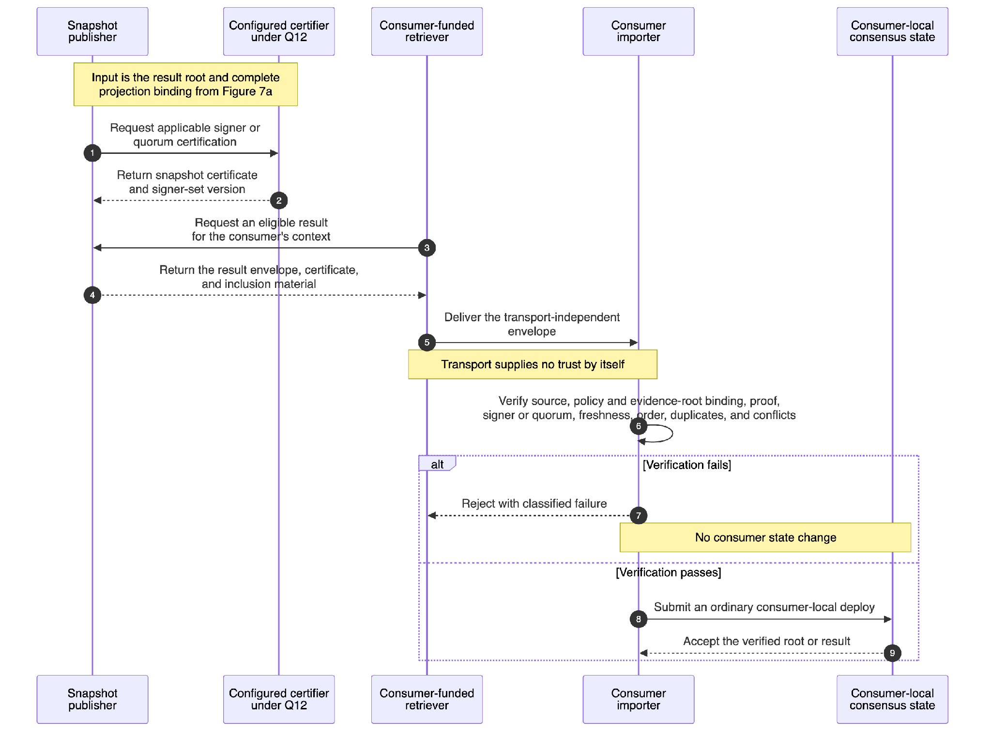
Editable Mermaid source | SVG export
Figure 7a ends with a result root and complete projection binding. Figure 7b covers certification, consumer-funded retrieval, verification, and local import. Retrieval carries the result but does not establish trust; the consumer importer verifies the snapshot before submitting an ordinary deploy into consumer-local consensus.
The abstract certifier in Figure 7b leaves Q12 open. It may be the reputation-shard validator set or a separately governed committee only after stakeholders fix quorum, anchoring, rotation, recovery, and fault-separation assumptions.

8. Trust boundaries and verification responsibilities
Boundary | Producer | Required verifier | Establishes | Does not establish
Source event or commitment | External source, node observer, or authorized truster | Evidence submission contract and later auditors | Integrity, attribution, and declared source context | Truth, foreign finality, payload availability, or completeness unless the source contract separately proves them
Signed reputation article | Authorized issuer | Evidence submission contract during consensus-visible execution | Schema-bound statement and event-time submit authority | Independent evidence strength or adjudicated truth
Finalized shard execution | Reputation-shard validator set | Query/replay logic and auditors | What the reputation shard finalized at a checkpoint | A foreign source's finality or a consumer's acceptance
Application evidence root | Reputation application | Evidence and projection clients | Committed reputation evidence state under a schema/context | Execution-state equivalence, completeness beyond declared coverage, or policy correctness
Structured reputation object plus proof | Evidence-query contract | Human or agent query client | Which evidence, refutations, omissions, and coverage answer one query | A policy-derived score or universal truth
Projection result and certificate | Projection engine, publisher, and configured certifier | Consumer importer | Output of one declared policy over one evidence root and epoch/cutoff | Transport trust, consumer acceptance, or correctness of the policy's social objective
Consumer-local deploy | Consumer importer and consumer validator set | Consumer applications | Result accepted under that consumer's policy and consensus | Universal validity outside the consumer domain

V1 security invariants
- Authorization is per action, source, event kind, type, scope, and payload class.
- Signer and controller-bundle rotation preserves event-time verification and does not rewrite subject history.
- Event identifiers, source lineage, epoch/order rules, and duplicate-detection rules prevent differently wrapped copies of the same event from multiplying evidence.
- Restricted payload access is authenticated and audited; public verification metadata is exposed only as approved by Q3/Q4.
- Restricted reads fail closed at a capability-aware query boundary under a versioned access policy. Query caches and mirrors cannot broaden access or serve a payload view for a different requester/policy context. Q3/Q4 still decide whether access audit authority and retention are consensus-visible or separately trusted before sensitive evidence is admitted.
- Unknown, missing, withheld, and unavailable evidence remains visible as state; it cannot silently become a positive result.
- No transport adapter, query cache, signer, or inclusion proof alone establishes finality, completeness, policy correctness, or consumer acceptance.

9. Interface contracts
Milestone 5 fixes semantic operations, not endpoint paths. The submission interfaces below conform to the contract/channel invariant in AD-13 and the deploy-response/finalization contract in Section 9.1. Each interface requires canonical serialization, version negotiation, typed failure responses, authorization behavior, and size/cost bounds before its applicable contract freeze.
Interface | Minimum request context | Minimum response or outcome | Decision dependencies
Evidence submission | Evidence event kind; article; subject, issuer, type, scope, time, source, payload/commitment, and authorization version | Node deploy response or native API error; returned deploy ID and finalization state; separate application outcome, event ID, safe reason, and evidence status reference | Q1-Q3, Q6, Q7, Q28
Lifecycle/correction submission | Lifecycle event kind; target event; actor; type, scope, time, reason/evidence, and authorization version | Node deploy response or native API error; returned deploy ID and finalization state; separate application outcome, lifecycle event ID, bound correction-policy version/lineage, safe reason, and separate dispute_case_status reference when applicable | Q3, Q6, Q9, Q14, Q28
Evidence query | Subject, type, scope, epoch/time, evidence root or freshness constraint, requester context | Structured reputation object, proof, coverage, freshness, availability/omission/redaction state, finalized-state binding, and any separate materialization version used | Q3-Q5, Q7, Q11, Q29, Q30
Projection-result query | Subject or aggregation, type, scope, policy version, epoch/cutoff, requester context | Separately typed result envelope and inclusion/certification material | Q8, Q10-Q12, Q14
Consumer import | Result envelope, proof/certificate, expected source/policy/signer set, consumer acceptance policy | Rejected reason or accepted consumer-local state reference | Q11-Q14, Q27
Operational observation | Metric scope and time range | Coverage, staged-build/activation state, replay/index cost, projection age, disputes, and import failures | Q4, Q26, Q30
Projection-result responses conform to the normative field definition in Evidence and Claims Model Section 10. Architecture additionally requires that the response remain distinct from an evidence-query response and independently verifiable at the consumer boundary.

9.1 Deploy response, finalization, and idempotency contract
- Event and lifecycle identifiers use one declared shard-wide uniqueness/idempotency domain across all state-changing contracts and partitions. The physical mechanism may be a canonical ID registry, content-derived identifier, or another Q26-selected design with equivalent deterministic behavior.
- A retry of the same logical submission returns the same final outcome or a duplicate response referencing it; submitting through another contract family or partition cannot create a second canonical event.
- Before queueing, the node may return its native HTTP error or gRPC error for an invalid deploy request, signature, unsupported algorithm, parsing failure, or node admission condition. The reputation package does not rename or extend that API vocabulary.
- If the node accepts the deploy, it returns a deploy ID. Clients treat the operation as pending until the node's native finalization-status interface reports Pending, Finalized, Failed, or Expired.
- Finalized means the deploy's effects are in canonical state; it does not by itself mean that the reputation article or lifecycle event was semantically accepted. The consensus-visible reputation contract supplies a separate application outcome and event or lifecycle ID, with its evidence root, safe reason, and status reference.
- A contract-level rejection is an application outcome, not a node API error, merge rejection, or Failed execution state, and is not itself canonical reputation evidence. Q26 selects the receipt/index representation; loss of an API log cannot erase a finalized contract outcome.

10. Operational and environmental envelope

10.1 Prototype operations
The follow-on proof of concept must run on a real controlled multi-validator shard, not only unit fixtures. It records:
- Evidence ingestion success/rejection counts and lag to finalization.
- Expected and observed coverage, sequence gaps, unavailable payloads, and redactions.
- Exact lookup, adjacency, invalidation, update, projection, checkpoint, replay, and index-rebuild cost.
- Per-contract/channel submission throughput, queueing, and hot-partition contention under mixed evidence and lifecycle workloads.
- Projection age, certification state, and correction/restatement lineage.
- Dispute state and age.
- Consumer import acceptance/rejection by failure class during RG5.
The canonical event and evidence state must be recoverable through the node's finalized history/checkpoint and deterministic replay path. Derived indexes and caches must be disposable and rebuildable. Q26 supplies actual recovery windows, retention, workload, fanout, latency, and storage thresholds.

10.2 Explicitly undecided production concerns
Milestone 5 does not choose a cloud/provider topology, regions, production validator count, autoscaling model, secrets platform, production payload store, backup retention, incident-management tooling, or production service-level objectives. Those decisions depend on RG4/RG5 results and belong to production-readiness work. Their absence must not be misread as permission to inherit arbitrary defaults.

11. Architecture decision register
This register summarizes the architecture decisions established by this document. The AD-n labels are identifiers for rows in this register, not references to separate ADR files. Each row leads with the decision itself, followed by its current status, the parts of the design it applies to, and the failure mode it guards against.
Decision | Status | Applies to | Guards against
AD-1 — Canonical reputation is append-only typed evidence; projections never replace it | Established design constraint | All writers, storage, queries, corrections, and projections | Score-first implementations and destructive history edits
AD-2 — V1 uses one permissioned, multi-validator F1R3FLY reputation shard, with its application state finalized in-node; no authoritative sidecar database. | Established design constraint; RG4 validation | Deployment and canonical state ownership | Competing canonical databases and unverifiable off-chain authority
AD-3 — Every action and result binds stable subject, type, scope, time, and effective authority version; no automatic carry-over between types or scopes | Gate 1 dependent | Identity, authorization, partitioning, queries, projections, and import | Type/scope laundering and key rotation rewriting identity
AD-4 — Evidence queries and projection-result queries use distinct contracts and response types | Established design constraint | Query APIs, response types, clients, and acceptance tests | Treating evidence lookup as a score or a score as canonical evidence
AD-5 — Projections execute deterministically against declared inputs and publish immutable periodic epoch/cutoff snapshots | Established design constraint; Q15 parameters open | Projection engine, snapshots, correction, and shadow operation | Nondeterministic or per-claim score drift
AD-6 — A result becomes consumer state only after independent verification and an ordinary consumer-local deploy | Established design constraint; RG5 validation | Transport, certification, importer, and consumer applications | Treating retrieval or transport as cross-shard consensus
AD-7 — An accepted event and its required bounded core indexes finalize atomically. Larger derived state remains inactive until complete and is activated through one version reference. Every query identifies the finalized block/evidence root and any separate materialization version used | Established design constraint; Q5/Q26/Q30 detail open | Persistence, indexes, queries, staged builds, and recovery | Partial visibility, mixed-version answers, or derived state silently becoming authority
AD-8 — Corrections are append-only and identify their target evidence. The system derives affected result contexts through reverse dependencies, and the applicable versioned correction policy governs their later recomputation or restatement; published snapshots remain immutable | Gate 1 dependent | Disputes, correction, invalidation, and replay | Submitter-controlled impact, silent mutation of published history, and inconsistent restatement
AD-9 — Every evidence class declares payload or commitment, availability, privacy, and coverage semantics independently | Gate 1 dependent | Payload persistence, privacy, proofs, and coverage | A content hash being presented as available or complete evidence
AD-10 — V1 reputation is observe/shadow only and does not alter consensus, eligibility, slashing, emissions, burns, or other high-impact controls | Established design constraint | Consensus, tokenomics, policy clients, and roadmap promotion | Reputation silently acquiring protocol authority
AD-11 — Fix logical access patterns now; select and optimize the physical layout only after representative benchmarks | Candidate implementation; Q26/RG4 | PathMap/RSpace layout and graph-shaped access | Premature commitment to a physical graph representation
AD-12 — The certification topology, quorum, anchoring, rotation, and recovery contract is explicit and versioned before projection contract freeze | Gate 1 dependent | Snapshot publisher, signer rotation, and consumer importer | Transport signatures or a single API server being treated as sufficient certification
AD-13 — V1 uses separate capability-secured contract/channel families for evidence submission and lifecycle/correction; all state-changing contracts share canonical envelope fields, authorization invariants, a shard-wide event-ID/idempotency domain, receipt semantics, and one canonical evidence-event model; bounded shared coordination/state keys are allowed only when identified and validated under Q26/RG4 | Established design constraint; physical state convergence remains Q26/RG4 | Evidence/lifecycle contract families, state channels, authorization, receipts, and canonical mutation | An untyped ingress, whole-history channel, cross-family replay, incompatible event semantics, or separate evidence authorities
AD-14 — Node/API admission checks do not establish reputation validity; deploy and block validity remain consensus-validated, and authoritative event-signature, schema, capability, uniqueness, target, and correction-policy validation executes inside the consensus-visible application transaction before canonical state changes | Established design constraint | Node API, deploy execution, authority registry, and every state-mutating reputation contract | API bypass granting unauthorized state mutation or validators accepting divergent application outcomes
AD-15 — Restricted reads fail closed at a capability-aware, versioned query boundary; caches cannot broaden requester access; Q3/Q4 must fix audit authority, retention, and public verification metadata before sensitive evidence is admitted | Gate 1 dependent on Q3/Q4 | Evidence queries, restricted payload retrieval, caches, and access audit | API or cache bypass exposing restricted evidence or unaudited access
AD-16 — All state-changing contracts use the Section 9.1 deploy-response/finalization mapping and one application-receipt contract; finalized outcomes bind deploy and checkpoint context and remain recoverable without treating rejected submissions as evidence | Established design constraint; Q26 storage detail open | All state-changing contracts, node deploy/finalization status, audit, retries, and replay | Conflicting receipts, retry duplication, or application outcomes disappearing with API logs
AD-17 — Projection execution begins through an ordinary signed trigger deploy; consensus-visible application logic validates trigger capability, the active policy manifest, cadence, epoch/cutoff, and idempotency before deterministic execution. The initiator cannot choose an uncommitted policy or publish directly | Established design constraint; Q15 trigger principal/cadence open | Projection trigger client, consensus execution, active policy registry, projection engine, and publisher | Off-chain scheduling authority, duplicate epoch results, or nodes executing different policy/cutoff inputs
AD-18 — Query semantics live in the reputation contract. Native node calls, polling or notification, cross-shard transport, and optional adapters are access mechanisms that must preserve the same authorization, response type, and state binding | Established design constraint; Q27/Q29 mechanism open | Evidence queries, client integration, cross-shard access, and adapters | An API or transport becoming a second semantic authority

12. Alternatives and deferred architecture
Alternative | V1 disposition | Reason
Canonical sidecar graph database | Rejected for V1 | Creates a second authority and avoids testing the milestone's in-node sufficiency hypothesis; an off-chain mirror may remain explicitly non-canonical
One mutable reputation score per subject | Rejected | Erases type, scope, evidence, policy, conflict, and temporal context
Continuous projection recomputation and push on every claim | Rejected for V1 | Couples evidence arrival to consumer delivery and policy cost; periodic snapshots plus consumer-funded retrieval preserve clearer boundaries
Native cross-shard read via remote/reified RSpace as the import mechanism | Not assumed for V1; named future candidate (Q27) | The approved Reifying RSpaces FIP (Stay/Meredith, September 2025) is the named path to native cross-shard transport, but the reviewed node does not yet implement it. If adopted, it improves carriage, not verification: a reified read delivers committed foreign state natively, while consumer-side checks of source finality, certification, order, and freshness remain required either way — Q27 fixes those semantics
Universal evidence/result reuse across scopes | Rejected | Enables scope/type laundering; any cross-context reuse must be explicit, bounded, and versioned
Reputation-weighted consensus, eligibility, or automatic slashing | Deferred beyond V1 | Requires separate research, governance, and safety approval
Independent reputation-provider federation | Deferred | Requires provider identity, mutual verification, conflict, discovery, and governance contracts under Q24
Recursive ZK, TEE-backed scoring, or mandatory code commitments | Deferred | No approved production threat model or demonstrated V1 need

13. Open decisions that change the architecture
Decision status is maintained in the Open Question Register. The groupings below show where those decisions land; they do not duplicate that status.
Architecture seam | Required decisions | Must be fixed before
Subject, type, source, authority, and privacy contract | Q1-Q4, Q6, Q28 | PoC contract freeze
Canonical versus retained payload and derived state | Q3, Q5, Q7, Q30 | PoC contract freeze
Dispute, correction, invalidation, and historical restatement | Q9, Q14 | PoC and projection contract freezes
Evidence-query serialization, proof, root binding, access, and completion notification | Q4, Q7, Q11, Q29 | PoC contract freeze
Projection model, trigger/cadence, conflict semantics, certification, and snapshot binding | Q8, Q10, Q12, Q14, Q15 | Projection contract freeze
Physical state/index layout, atomic write boundary, staged activation, and quantitative bounds | Q26, Q30 | PoC contract freeze
Consumer retrieval, transport, import state, and liveness | Q11-Q14, Q27, Q29 | Consumer-integration contract freeze
Advanced privacy and production-sensitive evidence | Q3, Q4, Q23 | Sensitive-evidence production approval
RG4 subsequently validates the Q26/Q30 decisions against the implemented workload; it is a validation gate, not a decision deadline.

14. Architecture validation gates
The Risk Register defines the complete RG1-RG6 validation set, and the Roadmap assigns each gate to an implementation stage. This section expands only the two architecture and integration gates: RG4 for the in-node proof of concept and RG5 for consumer import. RG1 supplies the underlying evidence/replay correctness expected within RG4; RG2, RG3, and RG6 close during later hardening and production-readiness work.
Milestone 5 establishes a stakeholder-signable design hypothesis. It does not claim to confirm node sufficiency before implementation. The follow-on V1 proof of concept confirms or falsifies the architecture through recorded evidence.

RG4 - Node proof of concept
The in-node architecture is confirmed for the next phase only after a real local multi-validator shard demonstrates:
- Deterministic ingest -> evidence query -> invalidate -> replay, including ordered ingestion manifests, sequence/gap detection, and test cases with deliberately omitted adverse evidence.
- Correct structured-reputation-object-plus-proof responses bound to one finalized block/evidence root and any separately published materialization version. Core indexes remain atomic with accepted events; queries requiring staged derived state demonstrate bounded waiting or retry, explicitly identified older-root answers, and unavailable only when no acceptable complete version exists.
- Bounded concurrent submission contention and atomic write-set size, plus exact lookup, adjacency, invalidation, update, staged-build activation, replay, checkpoint, index rebuild, and projection cost at agreed representative volumes. Failure injection never exposes a partial staged version.
- Two independent correctness checks: (a) canonical replay and derived-index rebuild produce equivalent evidence and query state; and (b) the Section 7.2 audit harness demonstrates that incremental and full projection recomputation agree under the same evidence root, correction-policy version, effective cutoff/horizon, projection policy/context, schema/runtime inputs, and snapshot/restatement context. Prospective checks target the next eligible result; bounded-lookback and retrospective checks rebuild the complete policy-bounded dependency boundary derived from the correction targets, even when it crosses epochs.
- Correct authorization, event-time key/controller version, embedded-event signature, shard-wide cross-family idempotency, receipt finality/retry, correction, privacy, availability, and no-automatic-type/scope-carry-over behavior for the first evidence classes, exercised through the selected direct native-node query path.
An RG4 failure revises the physical layout or the in-node hypothesis; it is not papered over with an authoritative sidecar.

RG5 - Consumer import
Consumer integration is validated separately when the importer rejects invalid signers or quorum, bad payloads or proofs, duplicates, stale or reordered results, and conflicts, and demonstrates defined retry, transport-failure, and lag behavior.
Until RG4 passes, the architecture remains plausible for a proof of concept and unvalidated for production. RG5 is not required to confirm the in-node evidence loop, but it is required to claim the consumer-import boundary works.

